

Achieving Water That Hydrates You Without Electricity

Quantum Age Water Stirwand is a water device that therapeutically maximizes cellular hydration. It has had four human clinical trials with controls, utilizing internal fluids of blood, urine, and saliva, to determine before and after results.

The results of increasing cellular hydration by 32% are: stable blood O2 at 98 to 100% in less than two weeks for virtually anyone, and a 11.4% increase in ATP production.

Another noticeable benefit of the Stirwand is balancing the overall body pH, moving the clinical group over 27% towards a natural acid/alkaline balance for your body type.

Detox plays a big role in this as well without any side effects, as you will release 19% of your cellular toxins with a significant heavy metal release across the board, starting with mercury at 75% in 90 days.

In essence, the nano sized earth minerals in the Stirwand re-establish the natural balance/stability in water that we lost when we polluted it with industry. Not unlike your blood, water must have a stable pH to efficiently hydrate you.

Only when enough stable energy is in the water will the natural “balance of chemistry” allow the angstrom size water modules to flow efficiently through the aquaporin channels.

The Stirwand works with any water type, is the size of a pen, comes in different versions for home and garden, and is unaffected by any electronic interference. We offer a 90-day money back guarantee and lifetime warranty (none have been returned in over 18 years).
Either stir your water for 30 seconds with the wand or let the wand sit in your water for 60 seconds or more and your water will be structured to cause improvement in hydration.
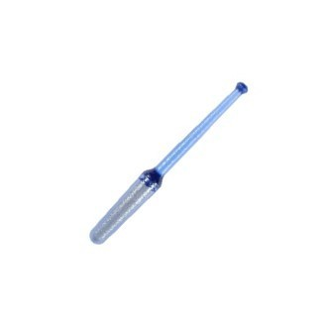
Order at synergisticnutrition.com or call 888-988-3325 or
864-895-6250.

